Lead appraisers can download the MDD Toolkit (MDD-Toolkit-Appraisal-Planning-and-Conduct.zip) from their dashboard here

<https://cmmiinstitute.com/resource-files/partner/lead-appraiser-materials/v2-0/mdd-toolkit-appraisal-planning-and-conduct>

[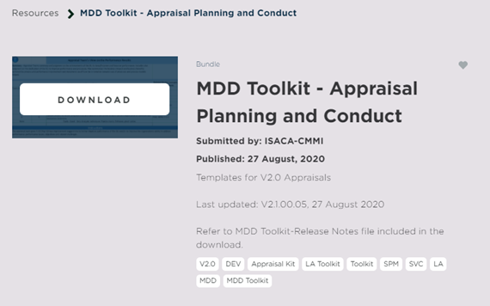](https://cmmiinstitute.com/resource-files/partner/lead-appraiser-materials/v2-0/mdd-toolkit-appraisal-planning-and-conduct)

Insidet the zip file is the following documents, one of which is the MDD-Toolkit-Appraisal Tool.xlsm

